**LAB 04:**

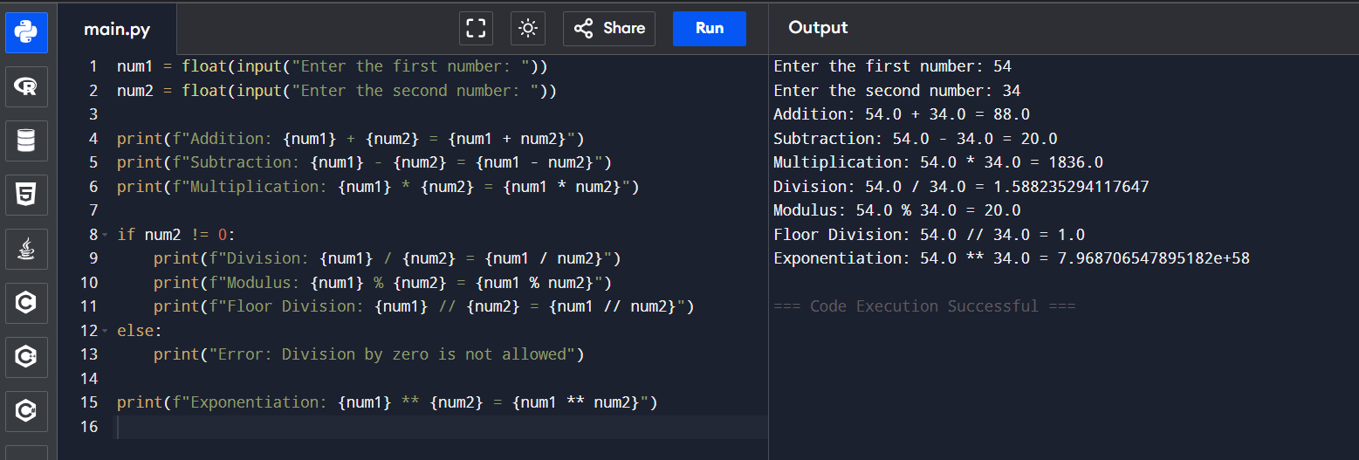Q. Write a python program to take two numbers as input and perform all arithmetic operators on them.

Q. Create a function that takes two numbers & returns their sum-sub-product-division.

Q. Write a python script to find the remainder when one number is divided by another.

Q. Write a program to calculate the area of circle using the formula

(Area =π*r^2).

Q. Implement a program that takes a number as input & returns its square & cube using exponential.

Q. Create a simple calculator in python that allows the user to choose an operation (addition, subtraction,etc) & inputs two numbers.

